|  |  |  |
| --- | --- | --- |
| **Hours spent on social media each day** | | **Favorite social media site** |
| Rajeev | 8 | Snapchat |
| Tiffany | 8 | Snapchat |
| Li | 6 | Facebook |
| Jayden | 9 | Instagram |
| Makayla | 1 | Facebook |
| Alexis | 10 | Snapchat |
| Jacob | 7 | Instagram |
| Katelyn | 8 | Instagram |

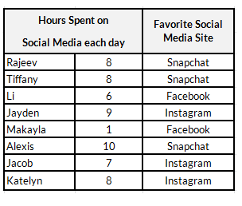

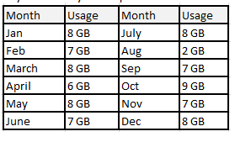

|  |  |
| --- | --- |
| **Month** | **Usage (GB)** |
| Jan | 8 |
| Feb | 7 |
| March | 8 |
| April | 6 |
| May | 8 |
| June | 7 |
| July | 8 |
| Aug | 2 |
| Sep | 7 |
| Oct | 9 |
| Nov | 7 |
| Dec | 8 |